

How is your business connected to

Business Model Canvas

people and money

Rapid Business Planning
© 2026 Bootstrap Factory LLC (BuildRunKit). Except where otherwise noted, this

Instructor: Brent Whistler
document and the original contents contained within are licensed under the Creative
Commons Attribution-ShareAlike 4.0 International License. You can learn about your

Book me: https://bookme.buildrunkit.com
responsibilities under this license here: https://creativecommons.org/licenses/by-sa/4.0

Try BuildRunKit: https://www.buildrunkit.com

Learn the concepts

Plan faster

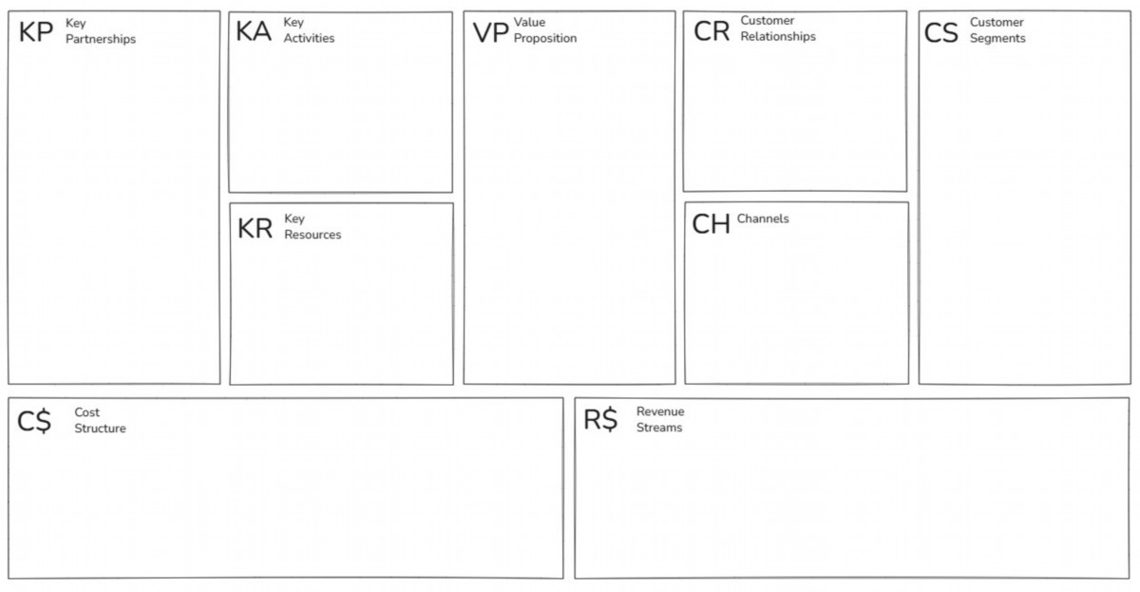
The Business Model Canvas - Designed by Strategyzer AG (strategyzer.com). This work is licensed under the Creative Commons Attribution-ShareAlike 3.0 Unported License. To view a copy of this
Put stuff here
Put stuff here
Put stuff here
Put stuff here
Put stuff here
Put stuff here
Put stuff here
Put stuff here
Put stuff here
license, visit http://creativecommons.org/licenses/by-sa/3.0/

To hosts & guests:
Minimise risks
VP to guests:
Safety/security
Deliver consistency (guest
Rental hosts
Hosts:
Choice & variety
Support
experience)
Superhosts
Maximisers
Higher value
Issues managem.
Remove frictions (guest/host)
Experiences hosts
Opportunity seekers
Authentic stays
Grow network effects
To communities:
Large landlords
Local experiences
Guests:
More guests/hosts
Good neighbour
VP to hosts:
Tourism partners
Traditional geo-demo
New offerings
Good citizen
Income generation
Technology
Communities
Higher(er) education
Ease of getting started
Biz travel managers
Higher(er) income
Good, screened guests
Commercial partners
30-49 year-old
Management tools
Algorithms
Sales, marketing:
Insurances
Leisure (single v family)
Extensive resources

Tech partners:
Tech platform
Active hosts
Word-of-mouth
Investors
matching, improving VP,
VP to biz travellers:
Inventory
Skilled staff
Active guests
Digital marketing
Amenities
Lobbyists
trends, etc
Playbooks
Brand
integration
Media coverage
Home feeling
Associates
Microsegments:
Acquisitions
Data assets
Discounts, promo
Transactions:
Biz travel
VP to all:
For various purposes, e.g.
(listings/user
Associates
App, website
platforms
Risk minimisation
Referrals
data)
Host/guest
optimised ranking,
And many others
Ease of transactions

Research & development
Technology platform
Insurance
Revenue: $8.4b (FY'22)
New offerings
Payment processing
Commissions on transaction value (incl on service fees)

Sales & marketing
IT infrastructure
Urban/suburban/rural (rural highest)
Customer acquisition,
General & Admin
*Guest service fees *host service fees *commission on Airbnb
discounts, promos, referrals,
G&A staff, legal
Experiences *FX currency fees *Float *co-branded credit cards etc.. *New
associates, etc
Services marketplace
The Business Model Canvas - Designed by Strategyzer AG (strategyzer.com). This work is licensed under the Creative Commons Attribution-ShareAlike 3.0 Unported License. To view a copy of this
license, visit http://creativecommons.org/licenses/by-sa/3.0/

AirBnb Example

Hotels:
Manage network effects
For travellers:

Supply Side (Partners)
Hotel/property owners
Commissions
Customer experience
Cheapest prices
Independent Hotels & B&Bs
Ease of joining
Customer support
Amount of choice
Major Hotel Chains
Major hotel chains
Grow the platform
No booking, no pay
Reduction of risk
Alternative Accommodation
Observe external factors
Travellers:
Affiliates
Customer service
Hosts
Enhance technology
Customer service
Guide customer journey
Useful app

Demand Side (Travellers)
Accuracy
Travel agents
Useful travel content
Corporate & Business
For hotels:
Travellers
Corporate travel managers
Incremental revenue
Budget-Conscious Leisure
Website (mobile, desktop) App
Number of hotels
Ability to react
Travellers
Partner channels
Technology partners
Number of locations
Global reach
"Genius" Program Loyalists
Ad channels, Search
Great content
Communications channels
Risk reduction
Package Travel Booking Users
Meta search engines
User data/algorithms
Additional web traffic
User experience
Lobbyists
Market intelligence
Global network
Skilled staff

FY22

FY22
Marketing: $6b (33%)
Sales: $2b (11%)
Total revenue: $17b
Personnel: $2.5b (15%)
Agency business model: 9b/17b = 53% (cus pays merchant directly)
G&A: $0.9b (0.5%)
Merchant business model: 7.2b/7b = 42% (cus pays booking as merchant)
IT: $0.5b (3%)
Advertising and other revenues: 0.9b/17b = 6.6%
D&A: $0.4b (3%)
The Business Model Canvas - Designed by Strategyzer AG (strategyzer.com). This work is licensed under the Creative Commons Attribution-ShareAlike 3.0 Unported License. To view a copy of this
license, visit http://creativecommons.org/licenses/by-sa/3.0/

Booking.com Example

Remove frictions
Riders:
Riders:
Riders:
Safety, security, privacy
Custom ride
Improve customer experience
Drivers
Younger, urban, medium-high
Pricing
On-demand
Reduce risks
Restaurants
income
Drivers:
ETA prior to ordering
Increase technical lead
National chains
Millennials: long-term
Opportunity
Lower(er) prices
Stimulate participation
Tech partners
Fairness
Convenience
Microsegments:
Scale existing cities
Cities / communities
Cities:
Safety (improving)
Purpose of rides, by routes,
"Good citizen"
Expand & grow
Drivers:
Commercial partners
movement data
Income generation
R&D partners
Work hours: flexible
Investors
Drivers:
No boss
Lobbyists
Part-time, male, multi-homing
App
Word-of-mouth
Network effects
(Lyft), college+
Insurance
Safety/support
Media coverage
Active riders / drivers
By intention: In-betweener,
Other, e.g. car hire,
Eats VP to consumers:
Marketing
Data assets
on-the-sider, permanent full-
Choice
Discounts, promo
rewards cards
Technology assets
time
Discovery
Social media, virality
Staff
Convenience
Partnerships
Local teams
Digital assets
Order tracking
Restaurant pages
Brand
Playbooks

Research & development
Driver cost base:
Mobility (~28% commission)
Insurance
Technology platform
Depreciation
Eats (~20% commission)
Fuel
Payment processing

Sales & marketing
Financing costs
Freight
IT infrastructure
Customer acquisition,
Licenses (if applicable)
General & Admin
All other
discounts, promos, etc
Maintenance, service
G&A staff, legal,
Driver referrals
Increasing: Advertising
professional services
The Business Model Canvas - Designed by Strategyzer AG (strategyzer.com). This work is licensed under the Creative Commons Attribution-ShareAlike 3.0 Unported License. To view a copy of this
license, visit http://creativecommons.org/licenses/by-sa/3.0/

Uber Example

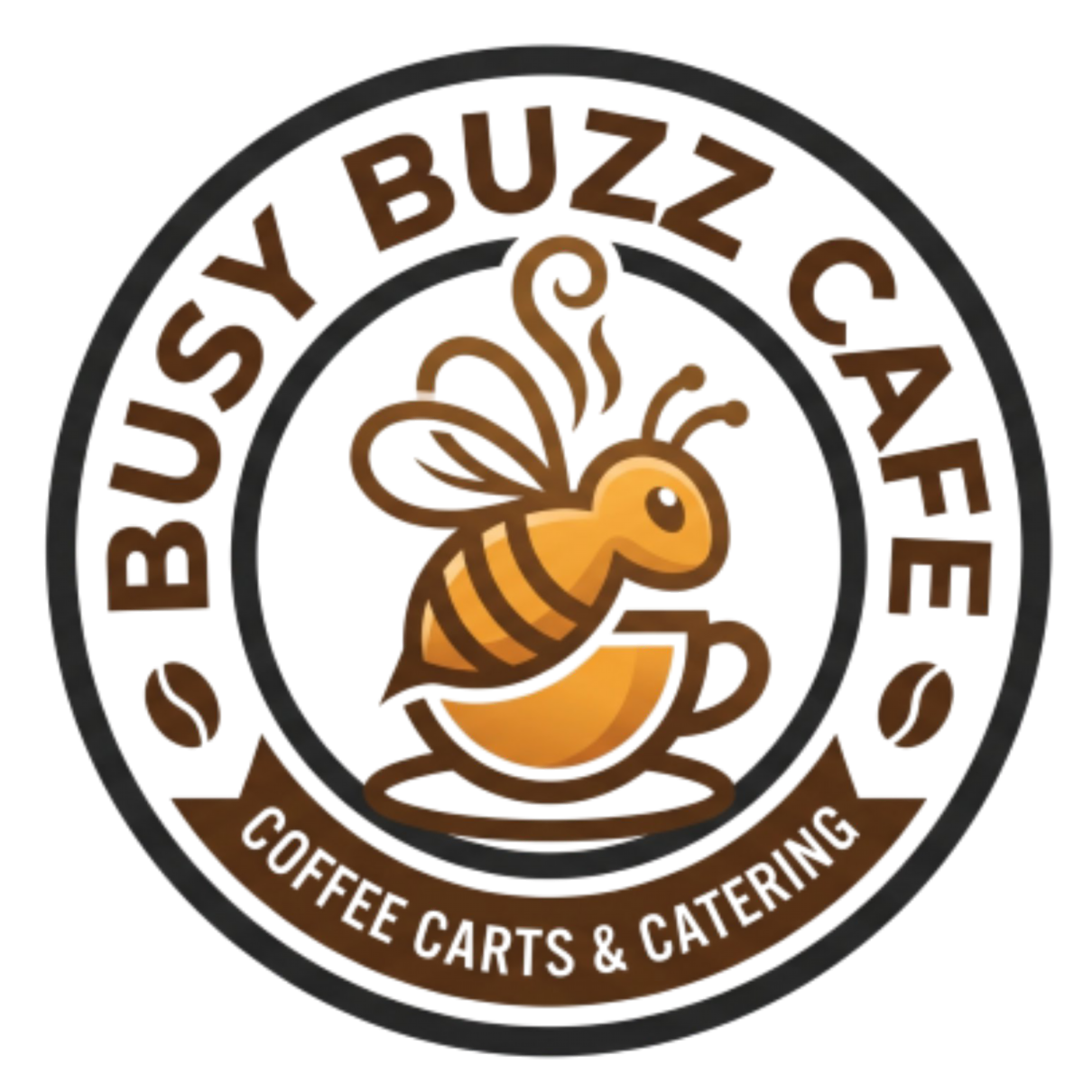


Let’s go through it for Busy Buzz

What about your business?

Remember Busy Buzz Café?



What / Why

Examples (for my coffee cart)

External companies, suppliers,

• Local Coffee Roasters

or organizations you need to

• Dairy & Alternative Milk Vendors

make your business model

• Commissary Kitchen / Storage

work.

Facility

• Property Owners & Local Council

Why: show how you reduce risk,

• Equipment Suppliers &

optimize your operations, scale

Technicians

quickly, or acquire critical

• Local Bakeries

resources

Key partnerships

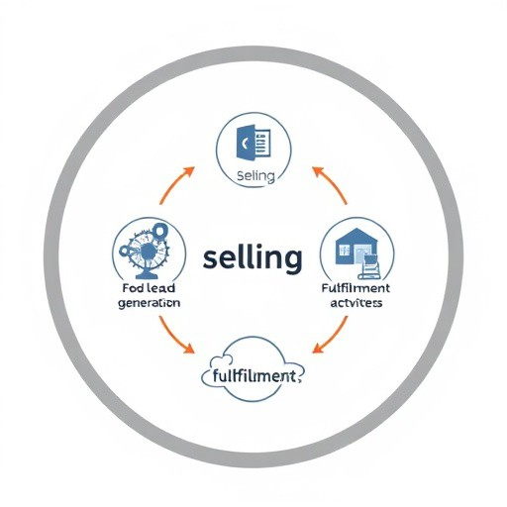

What / Why

Examples

The most important daily actions

• Brewing & serving coffee

your company must execute to

• Inventory & stock replenishment

make its business model work.

• Daily cart setup & teardown

• Equipment cleaning & maintenance

Why it's needed: To show

• Point-of-sale & transaction

exactly where your time, focus,

management

and operational budget must go

• Local permit & regulatory

to deliver your value proposition.

compliance

Key Activities


(physical, human, intellectual, or
financial) required to make your

What / Why

Examples

• Commercial espresso machine &

The most important assets

grinder

• Mobile coffee cart & trailer

business model work.

• Trained baristas

• Initial cash float & operating capital

Why it's needed: To show what

• Brand name, logo, & signage

you must own or control to create

• Opening inventory (Beans, milk,

your value proposition, reach your

cups)

market, and earn revenue.

Key Resources


creates value for a specific
customer segment.
Why it's needed: It is the core
reason why customers choose
Premium Quality (Single-origin beans, expert
barista craft, custom milk alternatives)

What / Why

Examples

• Segment: Rushed Commuters

The unique bundle of products,

Speed & Convenience (Under 60-second ordering,

services, and distinct benefits that

text-ahead pick-up, prime transit location)

• Segment: Specialty Coffee Lovers

• Segment: Budget-Conscious Locals

your business over a competitor; it

Affordable Daily Routine (Low price point, high-

explicitly solves their problem or

value sizing, stamp-based loyalty perks)

satisfies their need.

Value Proposition


• Automated Loyalty Perks (Digital punch
cards or SMS rewards to drive repeat
social media presence, neighborhood
chat groups)

What / Why

Examples

The specific type of interaction and

• Personal Assistance (Baristas greeting

ongoing connection a business

regulars by name, remembering custom

establishes and maintains with its

drink orders)

customer segments.

visits)

Why it's needed: To define how

• Community Engagement (Active local

you will acquire new customers,

retain existing ones, and boost

• Self-Service / Speed (Fast-pass pickup

sales over time.

lanes for quick, transactional transactions)

Customer Relationships

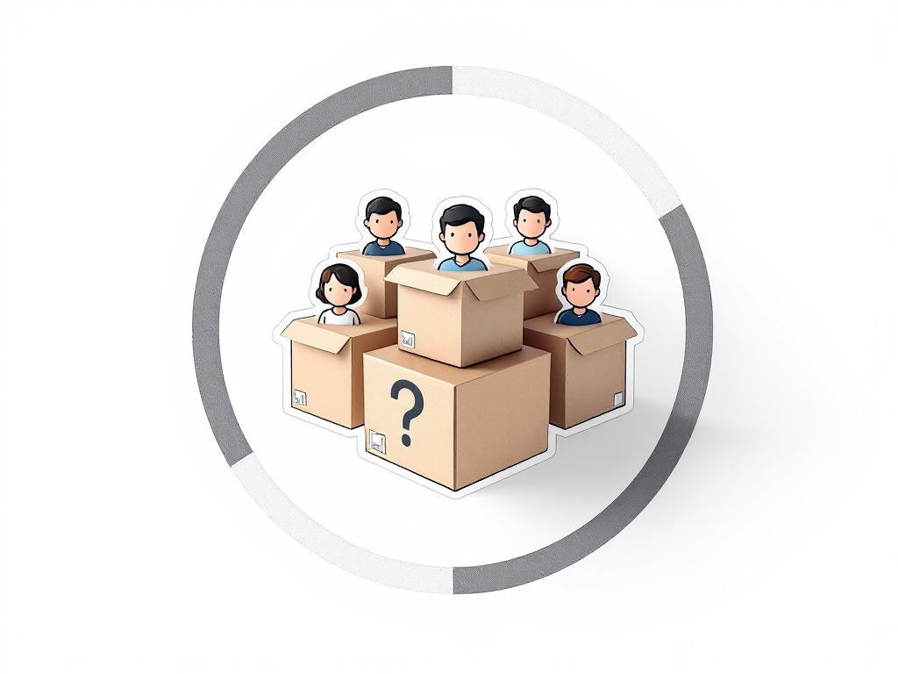
organizations an enterprise aims to
reach and serve.
succeed without customers; grouping
them allows you to tailor your product,
marketing, and pricing
needs rather than trying to please

What / Why

Examples

The distinct groups of people or

• Rushed Commuters

• Specialty Coffee Lovers

• Budget-Conscious Locals

Why it's needed: A business cannot

• Remote Workers

• Neighborhood Socializers

their specific

everyone.

Customer Segments

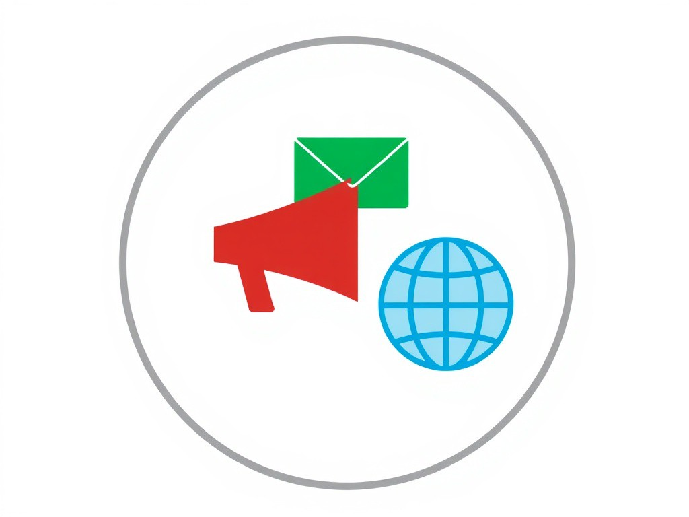
a company communicates with and
reaches its customer segments to
dictates how customers first discover
you, buy from you, and receive their
• Mobile App Purchases (Digital ordering
channel for pre-orders and remote sales)

What / Why

Examples

• Order at Cart (Direct, face-to-face sales point

The specific touchpoints through which

for walk-ups)

deliver its value proposition.

Why it's needed: It defines your entire

• Gift Cards (Pre-paid customer acquisition and

distribution and marketing strategy; it

word-of-mouth channel)

• After-Hours Cart Events (B2B booking channel

product.

for private parties, catering, and festivals)

Channels

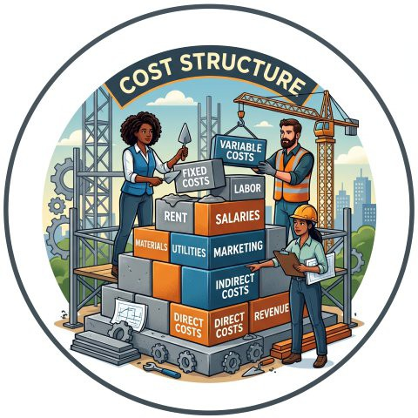
whether your business can actually
be profitable; it details the financial
• Raw ingredients (coffee beans, milk, syrups,
pastries)
• Transaction processing fees (POS/card
reader)

What / Why

Examples

Fixed Costs:

All the monetary costs and

• Cart storage & commissary kitchen fees

expenses incurred to operate your

• Permits, licensing, and insurance

entire business model.

• Equipment leasing (espresso machine)

Variable Costs:

Why it's needed: To determine

• Consumables (cups, lids, napkins, stirrers)

outlays required to maintain your

• Barista wages & labor

key activities, resources, and

partnerships.

Cost Structure

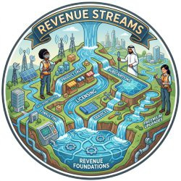
Why it's needed: It represents the
financial arteries of your business; it
proves that customers are actually
willing to pay for your value proposition
and shows exactly how the business
sustains itself.
• Event Catering (Flat-fee contract revenue for
private parties, weddings, and corporate gigs)
• Merchandise Sales (Branded travel mugs, t-shirts,
and stickers)
• Pre-paid Gift Cards (Upfront cash flow driving
future transactional sales)
• Coffee Subscriptions / Punch Cards (Recurring or
locked-in revenue for frequent daily commuters)

What / Why

Examples

• Direct Sales (One-time transaction revenue from

The cash a company generates from

coffee, tea, and specialty drinks)

each customer segment through

• Food Upsells (Margin-boosting sales from

various pricing mechanisms.

pastries, snacks, and retail bean bags)

Revenue Streams

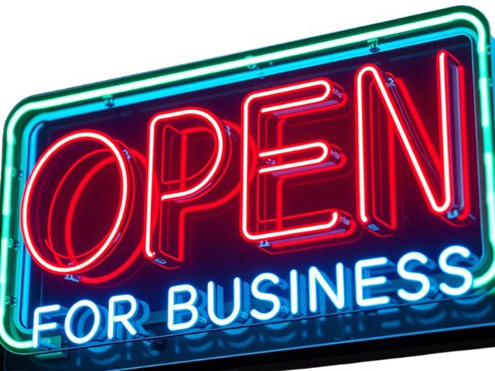

You
-What is this?
-What do you need?

Funded?
Now have data to answer these
-What do I get out of it?
questions!
Uh.. yeah.. a lot more likely

Who Cares? What About My Pitch?!

Investor

If you can’t be bothered
to put in this work, should

anyone invest?

